# Exercise: Graphs Shortest Path and MST

This document defines the exercise for ["Algorithms with Python" course @Software University](https://softuni.bg/opencourses/algorithms-with-python)".

Please submit your solutions (source code) to all below-described problems in [Judge](https://judge.softuni.org/Contests/3465).

## Distance Between Vertices

We are given a **directed graph**. We are given also a set of **pairs of vertices**. Find the **shortest distance between each pair** of vertices or **-1** if there is no path connecting them.

On the first line, you will get **N**, the number of vertices in the graph. On the second line, you will get P, the number of pairs between which to find the shortest distance.

On the next **N** lines will be the edges of the graph and on the next **P** lines, the pairs.

### **Examples**

|  |  |  |
| --- | --- | --- |
| **Input** | **Picture** | **Output** |
| 2  2  1:2  2:  1-2  2-1 |  | {1, 2} -> 1  {2, 1} -> -1 |
| 8  4  1:4  2:4  3:4 5  4:6  5:3 7 8  6:  7:8  8:  1-6  1-5  5-6  5-8 |  | {1, 6} -> 2  {1, 5} -> -1  {5, 6} -> 3  {5, 8} -> 1 |
| 9  8  11:4  4:12 1  1:12 21 7  7:21  12:4 19  19:1 21  21:14 31  14:14  31:  11-7  11-21  21-4  19-14  1-4  1-11  31-21  11-14 |  | {11, 7} -> 3  {11, 21} -> 3  {21, 4} -> -1  {19, 14} -> 2  {1, 4} -> 2  {1, 11} -> -1  {31, 21} -> -1  {11, 14} -> 4 |

## Most Reliable Path

We have a set of **towns** and some of them are connected by **direct paths**. Each path has a coefficient of reliability (in percentage): the chance to pass without incidents.

Your goal is to compute the **most reliable path** between two given nodes. Assume all percentages will be integer numbers and round the result to the second digit after the decimal separator. For example, let's consider the graph below:

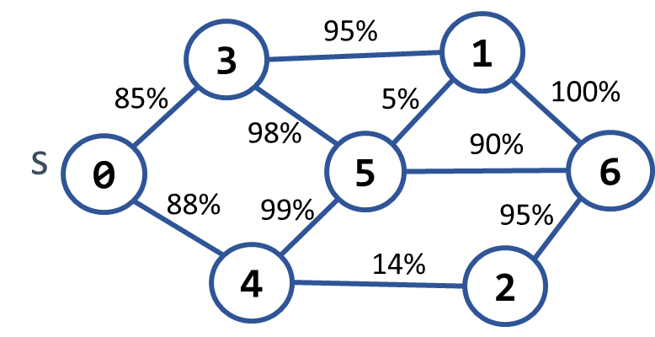 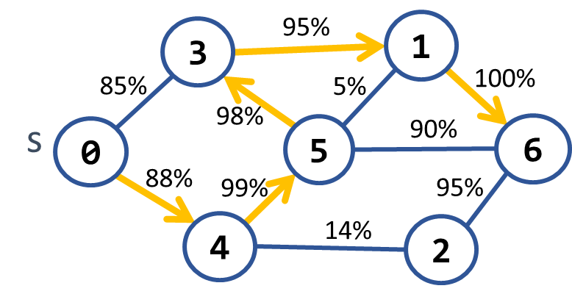

The **most reliable path** **between 0 and 6** is shown on the right: 0 **→** 4 **→** 5 **→** 3 **→** 1 **→** 6. Its cost = 88% * 99% * 98% * 95% * 100% = **81.11%**. The table below shows the optimal reliability coefficients for all paths starting from node 0:

|  |  |  |  |  |  |  |  |
| --- | --- | --- | --- | --- | --- | --- | --- |
| **v** | **0** | **1** | **2** | **3** | **4** | **5** | **6** |
| **reliability[s → d]** | 100% | 81.11% | 77.05% | 85.38% | 88% | 87.12% | 81.11% |

### Input

* On the first line, you will receive an integer – n – number of nodes.
* On the second line, you will receive an integer – e – number of edges.
* On the next e lines, you will receive edges in the following format: "{first} {second} {weight}".
* On the next line, you will receive an integer – source – starting of the path.
* On the last line, you will receive an integer – destination – end of the path.

### Output

* First print " Most reliable path reliability: {reliability}%" on the console.
  + reliability should be formatted to 2nd digit after the decimal point.
* Print the most reliable path in the following format: "{sourceNode} -> {node1} -> … -> {destination"}".

### Examples

|  |  |  |
| --- | --- | --- |
| **Input** | **Output** | **Picture** |
| 7  10  0 3 85  0 4 88  3 1 95  3 5 98  4 5 99  4 2 14  5 1 5  5 6 90  1 6 100  2 6 95  0  6 | Most reliable path reliability: 81.11%  0 -> 4 -> 5 -> 3 -> 1 -> 6 |  |
| 4  4  0 1 94  0 2 97  2 3 99  1 3 98  0  1 | Most reliable path reliability: 94.11%  0 -> 2 -> 3 -> 1 |  |

### Hints

Modify Dijkstra's algorithm.

## Cheap Town Tour

You now live in a new country and you want to start a tour and **visit every town** in the country and since you are new in the country your finances are **minimalized**, so you want your trip to be as **cheap** as possible.

You will be given the **amount** of the **cities** on the first line, then the amount of the **roads** (**n**), and on the next **n** lines you will receive which tows the road connects and the cost to use it.

Assume you can **start from any** town and your target is to **visit every one** of them with the **minimum** cost.

### Input

* On the **first line,** you will be given the **number of** the **towns**
* On the **second** line, you will be given the **number of streets** (**n**)
* On the **next n** **lines,** you will be given a connection in the format: **"{first} - {second} - {cost}"**

### Output

* Print the **total cost** of the road you have chosen in the format: **"Total cost: {totalCost}"**

### Examples

|  |  |  |
| --- | --- | --- |
| **Input** | **Output** | **Comment** |
| 4  5  0 - 1 - 10  0 - 2 - 6  0 - 3 - 5  1 - 3 - 15  2 - 3 - 4 | Total cost: 19 | The cheapest way to visit all the towns is using the roads with a cost: 4 + 5 + 10 = 19 |

## Undefined

Your **task** is to find the **shortest** **path in a graph from S vertex to D vertex**. However, edges might have **negative weights** and for this reason, you should be cautious for negative cycles.

### Input

* On the first line, you will receive an integer – n – number of nodes.
* On the second line, you will receive an integer – e – number of edges.
* On the next e lines, you will receive edges in the following format: "{source} {destination} {weight}"**.**
* On the next line, you will receive an integer – source – the start of the path.
* On the last line, you will receive an integer – destination – end of the path.

### Output

* If there is a negative cycle you should print "Undefined"**.**
* Otherwise, first, print on a single line the **path,** and after that, print the path **weight**.

### Example

|  |  |
| --- | --- |
| **Input** | **Output** |
| 5  8  1 2 -1  1 3 4  2 3 3  2 4 2  2 5 2  4 2 1  4 3 5  5 4 -3  1  4 | 1 2 5 4  -2 |
| 5  8  1 2 -1  1 3 4  2 3 3  2 4 2  2 5 2  4 2 -1  4 3 5  5 4 -3  1  4 | Undefined |

## Cable Network

A cable networking company plans to extend its existing **cable network** by connecting as many customers as possible within a **fixed budget limit**. The company has calculated the **cost** of building some prospective connections.

You are given the existing cable network (a set of **customers** and **connections** between them) along with the **estimated connection costs** between some pairs of customers and prospective customers. A customer can only be connected to the network via a direct connection with an **already connected customer**.

Example:

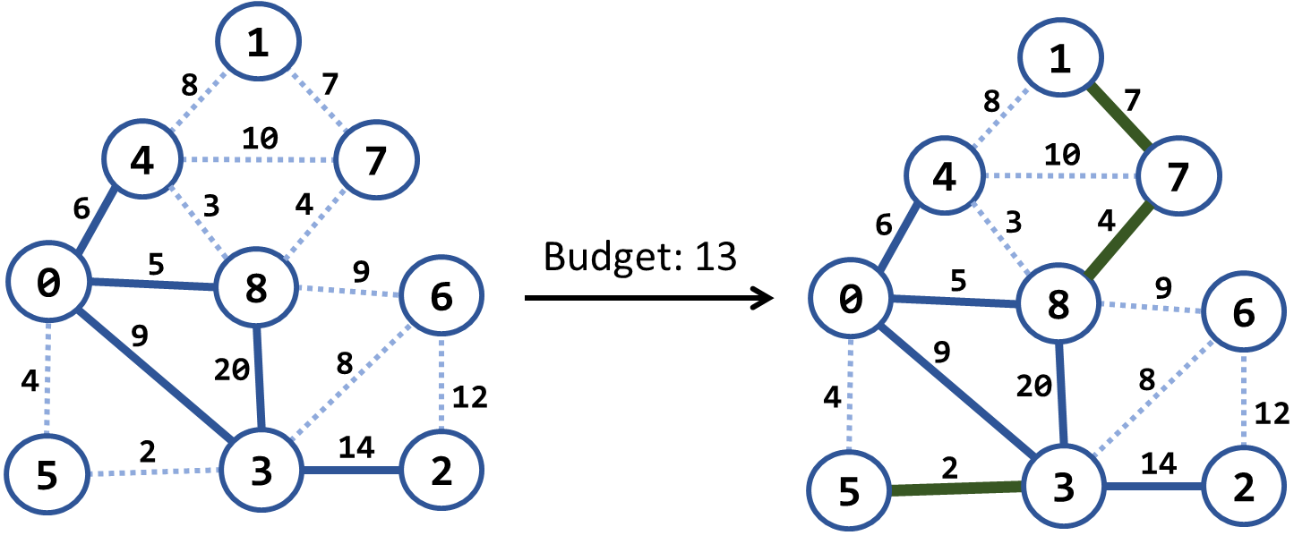

In the above example, we have an existing cable network (the solid blue lines), the estimated costs for connecting some of the customers (dotted blue lines), and a budget limit of 20.

Within this budget, the company can connect 3 new customers by the following new connections (solid green lines): {3 → 5}, {8 → 7} and {7 → 1}. The total cost for those new connections will be 2 + 4 + 7 = 13, which fits in the budget limit of 20. No more customers can be connected within this budget limit.

**NOTE** that each edge, at the time of its addition to the network, **connects a new customer with an existing one**.

### Input

* On the first line, you will receive an integer – budget.
* On the second line, you will receive an integer – n – number of nodes.
* On the third line, you will receive an integer – e – number of edges.
* On the next e lines, you will receive edges in the following format: "{first} {second} {weight} {connected}".

### Output

* Print "Budget used: {used_budget}" on the console.

### Examples

|  |  |  |  |
| --- | --- | --- | --- |
| **Input** | **Picture (Before)** | **Output** | **Picture (After)** |
| 20  9  15  1 4 8  4 0 6 connected  1 7 7  4 7 10  4 8 3  7 8 4  0 8 5 connected  8 6 9  8 3 20 connected  0 5 4  0 3 9 connected  6 3 8  6 2 12  5 3 2  3 2 14 connected |  | Budget used: 13 |  |
| 7  4  5  0 1 9  0 3 4 connected  3 1 6  3 2 11 connected  1 2 5 |  | Budget used: 5 |  |
| 20  8  16  0 1 4  0 2 5  0 3 1 connected  1 2 8  1 3 2  2 3 3  2 4 16  2 5 9  3 4 7  3 5 14  4 5 12  4 6 22  4 7 9  5 6 6  5 7 18  6 7 15 |  | Budget used: 12 |  |

### Hints

Modify Prims's algorithm. Until the budget is spent, connect the smallest possible edge from the connected node to the non-connected node.